UNIVERSITY INSTITUTE OF COMPUTING

PROJECT REPORT
ON
AMAZON’S E- COMMERCE STRATEGY
INTERNET ETHICS
SUBJECT CODE- 25CAT-105

SUBMITED BY:

Name : KANAK RANA UID : 25BCD10104

Branch : BCA(DATA SCIENCE) Group: B Section:25BCD-2

Semester : 1

SUBMITED TO:

Name: RAJAT KAPOOR D.O.SUBMITION : _________________

Desigination: ASSISTANT PROFESSOR
Sign:____________________

Project Report: Amazon’s e-commerce strategy

Aim / Introduction of the Project
Amazon is the world’s largest e-commerce company founded by Jeff Bezos in 1994. It started as a bookstore and later expanded into a multi-category marketplace.
Amazon's growth strategy revolves around customer obsession, innovation, and technological development. The company constantly reinvests profits to expand operations.
E-commerce in India has transformed drastically and Amazon has played a key role in shaping the market. The introduction of Prime, Amazon Pay and localized logistics strengthened its presence.
E-commerce involves the buying and selling of goods and services over digital platforms. In today's digital age, it is driven by technology, data analytics, and digital payments.
Amazon is the world’s largest e-commerce company founded by Jeff Bezos in 1994. It started as a bookstore and later expanded into a multi-category marketplace.
Amazon's growth strategy revolves around customer obsession, innovation, and technological development. The company constantly reinvests profits to expand operations.
E-commerce in India has transformed drastically and Amazon has played a key role in shaping the market. The introduction of Prime, Amazon Pay and localized logistics strengthened its presence.
E-commerce involves the buying and selling of goods and services over digital platforms. In today's digital age, it is driven by technology, data analytics, and digital payments.
Amazon is the world’s largest e-commerce company founded by Jeff Bezos in 1994. It started as a bookstore and later expanded into a multi-category marketplace.
Amazon's growth strategy revolves around customer obsession, innovation, and technological development. The company constantly reinvests profits to expand operations.

E-commerce in India has transformed drastically and Amazon has played a key role in shaping the market. The introduction of Prime, Amazon Pay and localized logistics
strengthened its presence.
E-commerce involves the buying and selling of goods and services over digital platforms. In today's digital age, it is driven by technology, data analytics, and digital payments.
Amazon is the world’s largest e-commerce company founded by Jeff Bezos in 1994. It started as a bookstore and later expanded into a multi-category marketplace.
Amazon's growth strategy revolves around customer obsession, innovation, and technological development. The company constantly reinvests profits to expand operations.
E-commerce in India has transformed drastically and Amazon has played a key role in shaping the market. The introduction of Prime, Amazon Pay and localized logistics strengthened its presence.
E-commerce involves the buying and selling of goods and services over digital platforms. In today's digital age, it is driven by technology, data analytics, and digital payments.
Amazon is the world’s largest e-commerce company founded by Jeff Bezos in 1994. It started as a bookstore and later expanded into a multi-category marketplace.
Amazon's growth strategy revolves around customer obsession, innovation, and technological development. The company constantly reinvests profits to expand operations.
E-commerce in India has transformed drastically and Amazon has played a key role in shaping the market. The introduction of Prime, Amazon Pay and localized logistics strengthened its presence.
E-commerce involves the buying and selling of goods and services over digital platforms. In today's digital age, it is driven by technology, data analytics, and digital payments.

Objective
To analyze Amazon’s e‑commerce business model in depth
To understand Amazon’s logistics and supply chain architecture.
To study the importance of AI, ML, and cloud computing in Amazon.
To understand Amazon India’s market approach and localization strategy.
To evaluate Amazon’s payment systems, customer experience and cybersecurity.
To examine Amazon’s seller ecosystem and customer fulfillment models.
To analyze Amazon’s e‑commerce business model in depth.
To understand Amazon’s logistics and supply chain architecture.
To study the importance of AI, ML, and cloud computing in Amazon.
To understand Amazon India’s market approach and localization strategy.
To evaluate Amazon’s payment systems, customer experience and cybersecurity.
To examine Amazon’s seller ecosystem and customer fulfillment models.
To analyze Amazon’s e‑commerce business model in depth.
To understand Amazon’s logistics and supply chain architecture.
To study the importance of AI, ML, and cloud computing in Amazon.
To understand Amazon India’s market approach and localization strategy.
To evaluate Amazon’s payment systems, customer experience and cybersecurity.
To examine Amazon’s seller ecosystem and customer fulfillment models.
To analyze Amazon’s e‑commerce business model in depth.
To understand Amazon’s logistics and supply chain architecture.
To study the importance of AI, ML, and cloud computing in Amazon.
To understand Amazon India’s market approach and localization strategy.
To evaluate Amazon’s payment systems, customer experience and cybersecurity.
To examine Amazon’s seller ecosystem and customer fulfillment models.
.

Overview of E-Commerce Concept Used
Amazon uses hybrid models including marketplace, direct retail, subscription-based, and cloud service models

The company focuses on offering convenience, variety, price competitiveness, and efficient delivery systems.
Amazon’s interface is powered by complex algorithms that track user behavior and personalize product recommendations.
Prime plays a crucial role in customer retention with exclusive access to fast delivery, streaming content, and deals.
Amazon’s business ecosystem is supported by AWS, Kindle, Alexa, Prime Video and Amazon Pay.
Amazon uses hybrid models including marketplace, direct retail, subscription-based, and cloud service models.
The company focuses on offering convenience, variety, price competitiveness, and efficient delivery systems.
Amazon’s interface is powered by complex algorithms that track user behavior and personalize product recommendations.
Prime plays a crucial role in customer retention with exclusive access to fast delivery, streaming content, and deals.
Amazon’s business ecosystem is supported by AWS, Kindle, Alexa, Prime Video and Amazon Pay.
Amazon uses hybrid models including marketplace, direct retail, subscription-based, and cloud service models.
The company focuses on offering convenience, variety, price competitiveness, and efficient delivery systems.
Amazon’s interface is powered by complex algorithms that track user behavior and personalize product recommendations.
Prime plays a crucial role in customer retention with exclusive access to fast delivery, streaming content, and deals.
Amazon’s business ecosystem is supported by AWS, Kindle, Alexa, Prime Video and Amazon Pay.
Amazon uses hybrid models including marketplace, direct retail, subscription-based, and cloud service models.
The company focuses on offering convenience, variety, price competitiveness, and efficient delivery systems.
Amazon’s interface is powered by complex algorithms that track user behavior and personalize product recommendations.
Prime plays a crucial role in customer retention with exclusive access to fast delivery, streaming content, and deals.
Amazon’s business ecosystem is supported by AWS, Kindle, Alexa, Prime Video and Amazon Pay.
Amazon uses hybrid models including marketplace, direct retail, subscription-based, and cloud service models.
The company focuses on offering convenience, variety, price competitiveness, and efficient delivery systems.
Amazon’s interface is powered by complex algorithms that track user behavior and personalize product recommendations.

Prime plays a crucial role in customer retention with exclusive access to fast delivery, streaming content, and deals.
Amazon’s business ecosystem is supported by AWS, Kindle, Alexa, Prime Video and Amazon Pay.

6. Working Model / Process Flow
Customer visits Amazon’s app or website and browses product categories.
Search engine and AI algorithms recommend products based on user interests.
Order is placed and processed through Amazon’s fast and secure payment gateway.
Product is picked and packed at fulfillment center then shipped using logistics partners.
Delivery partners ensure timely and reliable delivery while providing real‑time tracking.
Customer can request refunds, returns or exchange hassle‑free through app.
Customer visits Amazon’s app or website and browses product categories.
Search engine and AI algorithms recommend products based on user interests.
Order is placed and processed through Amazon’s fast and secure payment gateway.
Product is picked and packed at fulfillment center then shipped using logistics partners.
Delivery partners ensure timely and reliable delivery while providing real‑time tracking.
Customer can request refunds, returns or exchange hassle‑free through app.
Customer visits Amazon’s app or website and browses product categories.
Search engine and AI algorithms recommend products based on user interests.
Order is placed and processed through Amazon’s fast and secure payment gateway.
Product is picked and packed at fulfillment center then shipped using logistics partners.
Delivery partners ensure timely and reliable delivery while providing real‑time tracking.
Customer can request refunds, returns or exchange hassle‑free through app.
Customer visits Amazon’s app or website and browses product categories.
Search engine and AI algorithms recommend products based on user interests.
Order is placed and processed through Amazon’s fast and secure payment gateway.
Product is picked and packed at fulfillment center then shipped using logistics partners.
Delivery partners ensure timely and reliable delivery while providing real‑time tracking.
Customer can request refunds, returns or exchange hassle‑free through app.
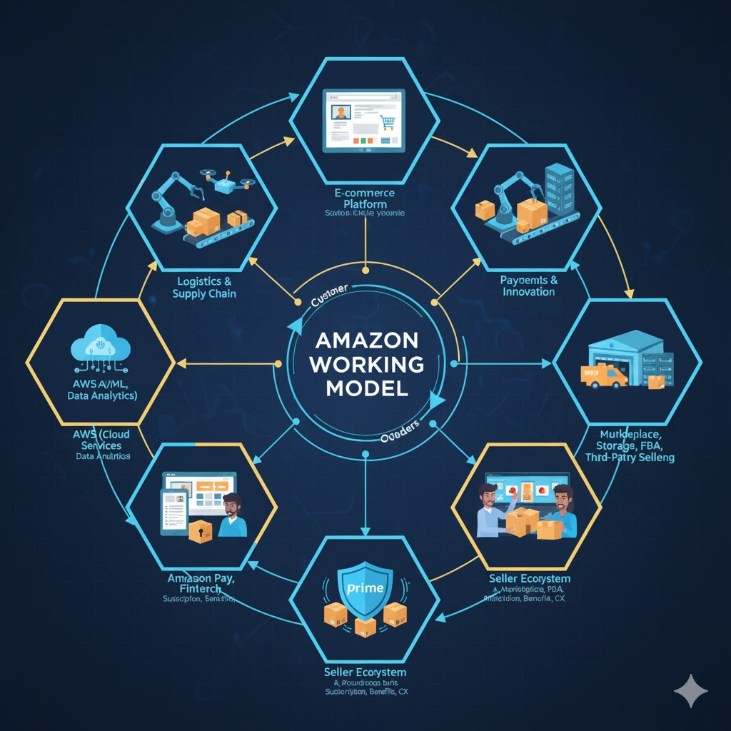

5. Logistics and Supply Chain
Amazon Fulfillment Centers are key hubs where inventory is stored and processed.
Amazon uses robotics and automation to speed up warehouse operations.
Prime Now delivery hubs ensure superfast delivery in metropolitan regions.
Amazon’s ‘I Have Space’ program empowers small businesses to act as delivery points.
Partnership with local kirana stores helps with last‑mile connectivity in rural India.
Seller Flex program gives small sellers access to FBA‑level services.
Amazon Fulfillment Centers are key hubs where inventory is stored and processed.
Amazon uses robotics and automation to speed up warehouse operations.
Prime Now delivery hubs ensure superfast delivery in metropolitan regions.
Amazon’s ‘I Have Space’ program empowers small businesses to act as delivery points.
Partnership with local kirana stores helps with last‑mile connectivity in rural India.
Seller Flex program gives small sellers access to FBA‑level services.
Amazon Fulfillment Centers are key hubs where inventory is stored and processed.
Amazon uses robotics and automation to speed up warehouse operations.
Prime Now delivery hubs ensure superfast delivery in metropolitan regions.
Amazon’s ‘I Have Space’ program empowers small businesses to act as delivery points.
Partnership with local kirana stores helps with last‑mile connectivity in rural India.
Seller Flex program gives small sellers access to FBA‑level services.
Amazon Fulfillment Centers are key hubs where inventory is stored and processed.
Amazon uses robotics and automation to speed up warehouse operations.
Prime Now delivery hubs ensure superfast delivery in metropolitan regions.
Amazon’s ‘I Have Space’ program empowers small businesses to act as delivery points.
Partnership with local kirana stores helps with last‑mile connectivity in rural India.
Seller Flex program gives small sellers access to FBA‑level services.
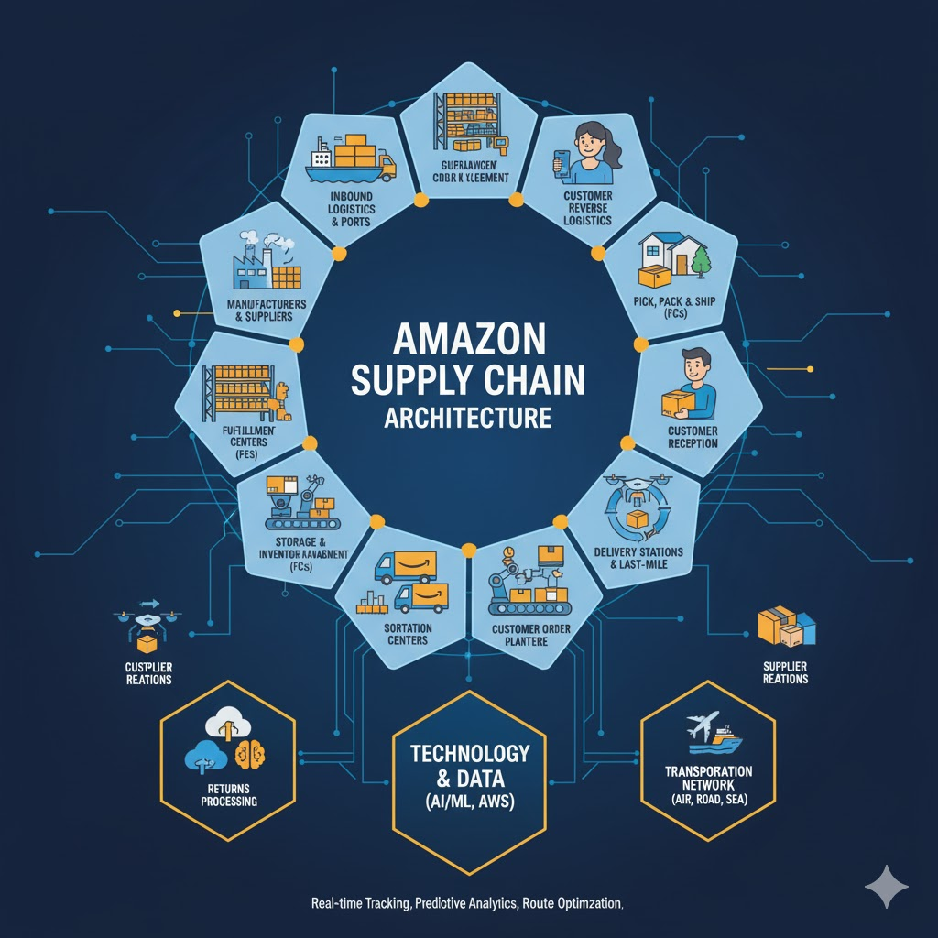

7. Benefits and Limitations
Vast range of product categories with competitive pricing.
24x7 availability with reliable delivery services.
Various payment methods including UPI, wallets, EMI, and COD.
Robust refund and return policies increase customer trust.
Limitations include strict seller policies, high operational costs, and intense competition.
Vast range of product categories with competitive pricing.
24x7 availability with reliable delivery services.
Various payment methods including UPI, wallets, EMI, and COD.
Robust refund and return policies increase customer trust.
Limitations include strict seller policies, high operational costs, and intense competition.
Vast range of product categories with competitive pricing.
24x7 availability with reliable delivery services.
Various payment methods including UPI, wallets, EMI, and COD.
Robust refund and return policies increase customer trust.
Limitations include strict seller policies, high operational costs, and intense competition.
Vast range of product categories with competitive pricing.
24x7 availability with reliable delivery services.
Various payment methods including UPI, wallets, EMI, and COD.
Robust refund and return policies increase customer trust.
Limitations include strict seller policies, high operational costs, and intense competition.
- Technology and Payment System Used
Amazon uses machine learning for recommendation engines and demand forecasting.
AWS cloud powers Amazon’s e‑commerce infrastructure enabling speed and security.
AI‑powered chatbots assist customers with queries and order support.
Blockchain technology is being explored for logistics and security.
Amazon Pay and UPI integrations support fast and secure transactions.
Amazon uses machine learning for recommendation engines and demand forecasting.
AWS cloud powers Amazon’s e‑commerce infrastructure enabling speed and security.
AI‑powered chatbots assist customers with queries and order support.
Blockchain technology is being explored for logistics and security.
Amazon Pay and UPI integrations support fast and secure transactions.
Amazon uses machine learning for recommendation engines and demand forecasting.
AWS cloud powers Amazon’s e‑commerce infrastructure enabling speed and security.
AI‑powered chatbots assist customers with queries and order support.
Blockchain technology is being explored for logistics and security.
Amazon Pay and UPI integrations support fast and secure transactions.
Amazon uses machine learning for recommendation engines and demand forecasting.
AWS cloud powers Amazon’s e‑commerce infrastructure enabling speed and security.
AI‑powered chatbots assist customers with queries and order support.
Blockchain technology is being explored for logistics and security.
Amazon Pay and UPI integrations support fast and secure transactions.

- Risk and Security Measures
Secure encryption technology protects financial data.
Two‑factor authentication secures customer login details.
Fraud detection algorithms monitor suspicious activities.
Dedicated cybersecurity team monitors platform 24x7.
Return fraud and fake review systems are carefully tracked.
Secure encryption technology protects financial data.
Two‑factor authentication secures customer login details.
Fraud detection algorithms monitor suspicious activities.
Dedicated cybersecurity team monitors platform 24x7.
Return fraud and fake review systems are carefully tracked.
Secure encryption technology protects financial data.
Two‑factor authentication secures customer login details.
Fraud detection algorithms monitor suspicious activities.
Dedicated cybersecurity team monitors platform 24x7.
Return fraud and fake review systems are carefully tracked.
Secure encryption technology protects financial data.
Two‑factor authentication secures customer login details.
Fraud detection algorithms monitor suspicious activities.
Dedicated cybersecurity team monitors platform 24x7.
Return fraud and fake review systems are carefully tracked.

. Findings / Analysis
Amazon's customer‑centric approach is key to its global dominance
Use of data analytics gives Amazon strong competitive advantage.
Prime ecosystem builds loyalty and long‑term customer engagement.
Heavy investment in logistics makes delivery faster and more reliable.
Amazon continues to innovate through AI, automation and cloud technology.
Amazon's customer‑centric approach is key to its global dominance.
Use of data analytics gives Amazon strong competitive advantage.
Prime ecosystem builds loyalty and long‑term customer engagement.
Heavy investment in logistics makes delivery faster and more reliable.
Amazon continues to innovate through AI, automation and cloud technology.
Amazon's customer‑centric approach is key to its global dominance
Use of data analytics gives Amazon strong competitive advantage.
Prime ecosystem builds loyalty and long‑term customer engagement.
Heavy investment in logistics makes delivery faster and more reliable.
Amazon continues to innovate through AI, automation and cloud technology.
Amazon's customer‑centric approach is key to its global dominance.
Use of data analytics gives Amazon strong competitive advantage.
Prime ecosystem builds loyalty and long‑term customer engagement.
Heavy investment in logistics makes delivery faster and more reliable.
Amazon continues to innovate through AI, automation and cloud technology.

.

Conclusion
Amazon has revolutionized global and Indian e-commerce using technology, logistics and innovation.
The company's focus on speed, convenience and personalization remains unmatched.
E-commerce will continue evolving with automation, AI and new payment systems.
Amazon will keep expanding its ecosystem to strengthen long‑term customer value.
Amazon has revolutionized global and Indian e-commerce using technology, logistics and innovation.
The company's focus on speed, convenience and personalization remains unmatched.
E-commerce will continue evolving with automation, AI and new payment systems.
Amazon will keep expanding its ecosystem to strengthen long‑term customer value.
Amazon has revolutionized global and Indian e-commerce using technology, logistics and innovation.
The company's focus on speed, convenience and personalization remains unmatched.
E-commerce will continue evolving with automation, AI and new payment systems.
Amazon will keep expanding its ecosystem to strengthen long‑term customer value.
Amazon has revolutionized global and Indian e-commerce using technology, logistics and innovation.
The company's focus on speed, convenience and personalization remains unmatched.
E-commerce will continue evolving with automation, AI and new payment systems.
Amazon will keep expanding its ecosystem to strengthen long‑term customer value.

10 . Learning Outcomes
Understanding of e‑commerce models and digital operations.
Knowledge of Amazon’s logistical network and cloud infrastructure.
Awareness of risk management and cybersecurity in e‑commerce.
Exposure to marketing and customer retention strategies.
Understanding of e‑commerce models and digital operations.
Knowledge of Amazon’s logistical network and cloud infrastructure.
Awareness of risk management and cybersecurity in e‑commerce.
Exposure to marketing and customer retention strategies.
Understanding of e‑commerce models and digital operations.
Knowledge of Amazon’s logistical network and cloud infrastructure.
Awareness of risk management and cybersecurity in e‑commerce.
Exposure to marketing and customer retention strategies.
Understanding of e‑commerce models and digital operations.
Knowledge of Amazon’s logistical network and cloud infrastructure.
Awareness of risk management and cybersecurity in e‑commerce.
Exposure to marketing and customer retention strategies.

12. Evaluation Grid (To be created as per the SOP and Assessment guidelines by the faculty):
Sr. No. | Parameters | Marks Obtained | Maximum Marks
1. | PROJECT TITLE |  | 2 Marks
2. | CASE STUDY |  | 5 Marks
3. | Github Upload Link |  | 1 Marks
4. | Blog Upload Link |  | 1 Marks
5. | Follow Format |  | 1 Marks
 | TOTAL |  | 10 Marks
 | AVG |  | 6 Marks

Teacher Signature

